Linear Regression Test Results:

Original Training and Test data set

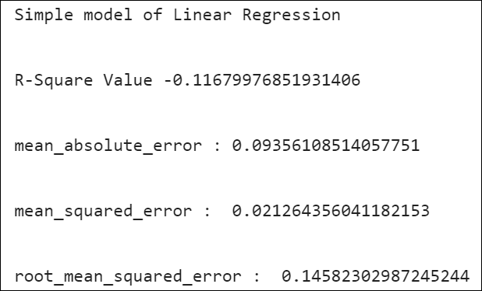

Data set – 5096 training instances and 4000 test instances:

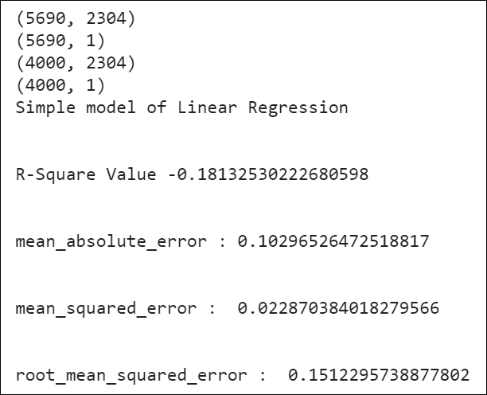

Data set – 690 training instances and 9000 test instances:

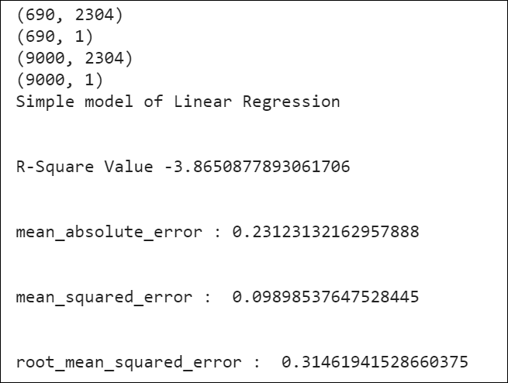

Cross Validation Results:

